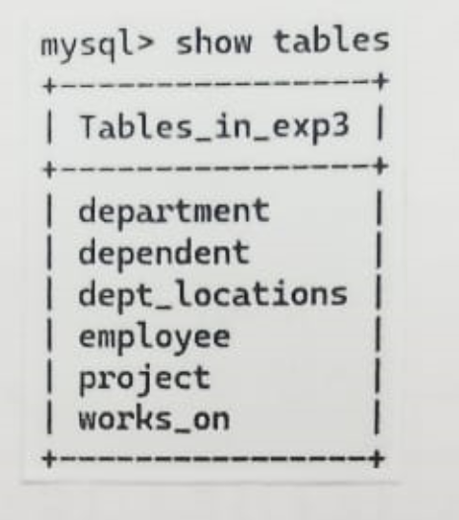

P1)

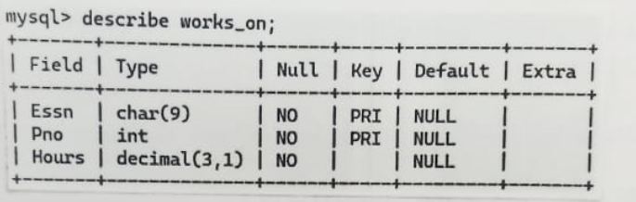

P3)

p4) 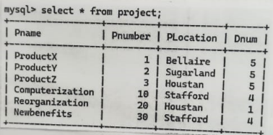

p5)

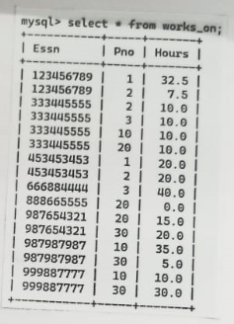P6)

P7)

